LIHEAP Grantee Energy Consumption and Expenditures Data Collection
WEB POSTING OF BEST PRACTICES KEY FINDINGS AND SAMPLE DOCUMENTS
Overview of the State of Minnesota’s Data Collection
The State of Minnesota currently collects energy consumption and expenditures data for all LIHEAP applicant households for the past twelve months for all fuel types from all vendors in the state. These data are being used to determine the LIHEAP benefit amount for each client.
The Vendor Agreement and Data Collection Requirements
The grantee requires all vendors to renew their agreement with the program’s subgrantees annually. The renewals are initiated as part of the grantee’s “prelogging” protocol, which are undertaken during the summer prior to the start of the next program year.
This process is fully automated within the state of Minnesota’s Electronic Household Energy Automated Technology (“eHEAT”) system. The basic vendor agreement for the upcoming program year is mailed to all subgrantees. Each subgrantee mails a copy to each of their clients’ fuel vendors. The vendors complete each agreement they receive and mail it back to the subgrantee from whom they received it.
Any revisions from the applications are needed in eHEAT are made by the subgrantees.
The grantee’s vendor agreement includes three provisions that compel the vendor to furnish energy expenditures and consumption data for LIHEAP clients. Per the grantee’s FFY13 agreement, “The vendor will:”
4 Provide at the request of the customer, the Service Provider or the State, information on applicant households’ home energy costs, dwelling consumption data, delivery dates, bill payment history or arrearage history. This information will be provided in the format requested.
4 Provide dwelling consumption data within 5 business days of the request in eHEAT.
4 Respond promptly to consumption request for crisis situations.
Data Collection Protocol
The state of Minnesota uses separate sets of protocols for collecting energy expenditures and consumption data for new applicants and current LIHEAP recipients. All data received by the grantee are in electronic format.
New Clients
When a new applicant applies for program benefits, all of his or her information is entered into the eHEAT application by the subgrantee. Applicant information could also be entered by the grantee or fuel vendor.
At the end of each day, eHEAT, in one fully automated function, outputs a single data file for each fuel vendor that was reported by at least one applicant that day as being their fuel supplier. Each vendor file contains one record per applicant. eHEAT creates these files in a format compatible with each vendor’s individual IT system.
The vendor’s IT system matches the eHEAT records and creates a file of expenditures and consumption data for those clients, and transmits it back to the grantee in a format that is compatible with the eHEAT database. Finally, eHEAT automatically uploads the data into the system.
The process of requesting then receiving expenditures and consumption data for new LIHEAP applicants ordinarily takes three days or less, frequently overnight. In cases where the data are needed right away, the subgrantee submits a data request to the fuel vendor, who is able to upload the information directly into eHEAT. Those data are then immediately available to the subgrantee.
Subgrantees and fuel vendors can access, view, and manipulate data for only themselves and their clients. Records can be presented by eHEAT in either list form or by individual client.
Current LIHEAP Recipients
The grantee requests and receives expenditures and consumption data for current LIHEAP recipients during “prelogging.”
As part of this process, the eHEAT system automatically migrates data for those clients currently in eHEAT into a new database for the pending program year. eHEAT then auto-generates a data request for each of these clients that is submitted electronically directly to the clients’ fuel vendors.
The vendor transmits expenditures and consumption data for each client electronically back to the grantee’s eHEAT system, where it is stored for use when and if each client reapplies for benefits for the next program year.

Screenshots of the Minnesota eHEAT Information Technology System Data Entry Screen
Minnesota’s Electronic Household Energy Automated Technology (“eHEAT”) system is an application that runs on top of a production DB2 database featuring approximately 150 data tables. e-HEAT stores all of the program’s client and vendor information, as well as annual energy expenditures and consumption data.
Following is a series of screenshots of the Minnesota eHEAT system, in particular the data entry screens that would typically be utilized by smaller utilities and vendors of deliverable fuels.
Screenshot 1 is a search screen that allows a vendor to choose only “Requested” consumption. To view/edit consumption data already entered in eHEAT, the vendor would choose “Available.”
Screenshot 1
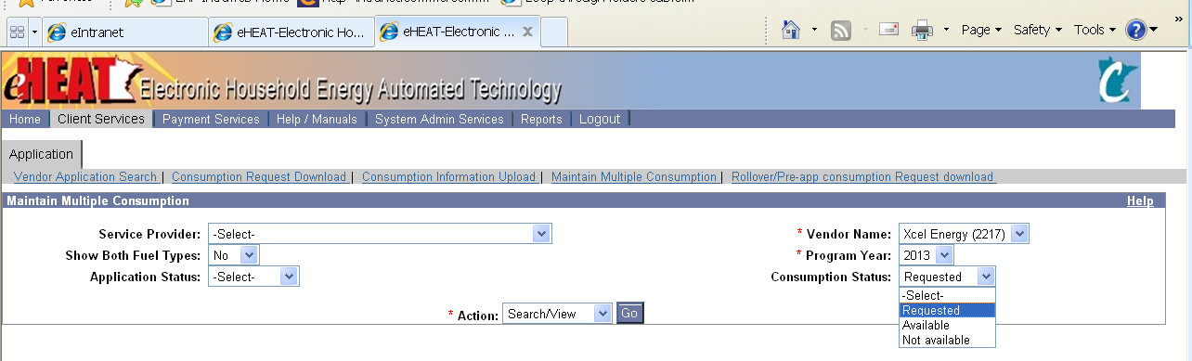
Screenshot 2 shows the data entry screen where a vendor enters their expenditures and consumption data; the vendor can also edit the client’s account number here. When the vendor checks a box directly under the column header, eHEAT will fill subsequent fields with identical data. For example, if a vendor chooses “Oil” for fuel type, “Oil” will be propagated as fuel type for all entries on the page.
Screenshot 2
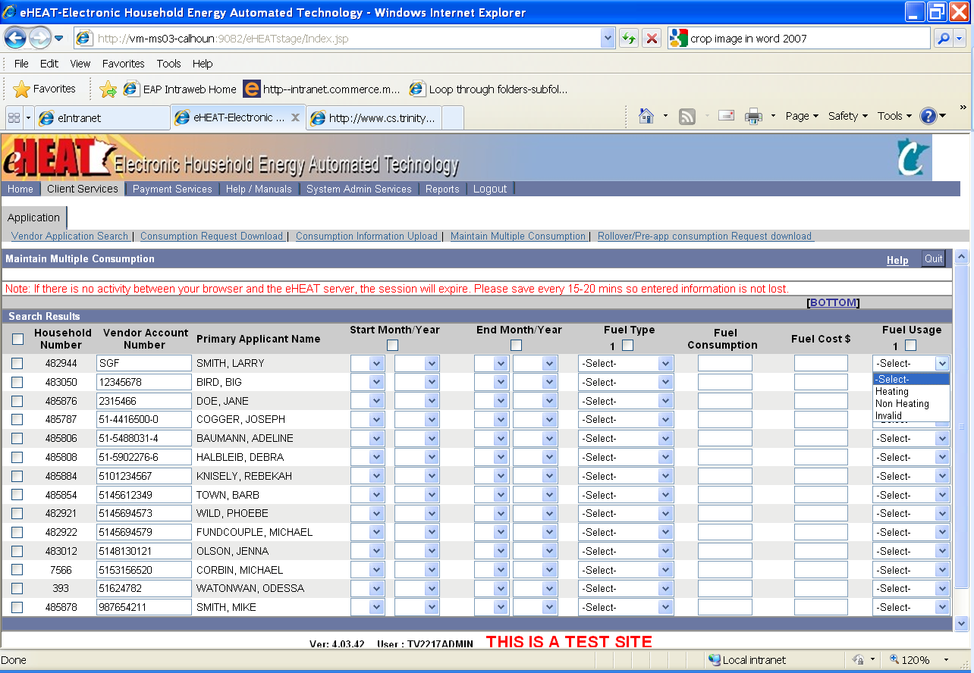
Finally, Screenshot 3 and Screenshot 4 illustrate how a vendor is able to search for a specific client and then enter expenditures and consumption data for one client at a time.
Screenshot 3
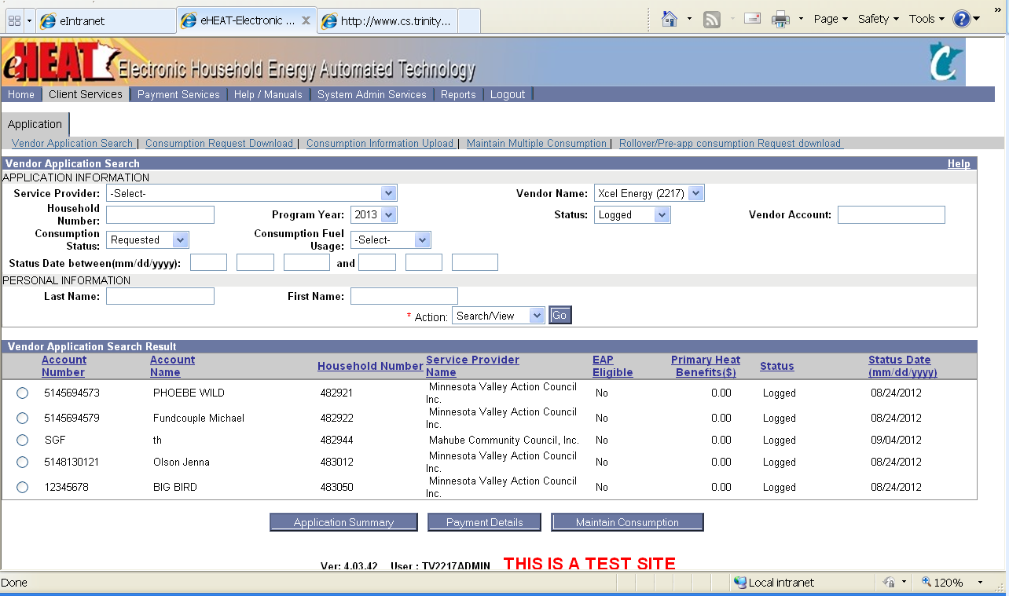
Screenshot 4
